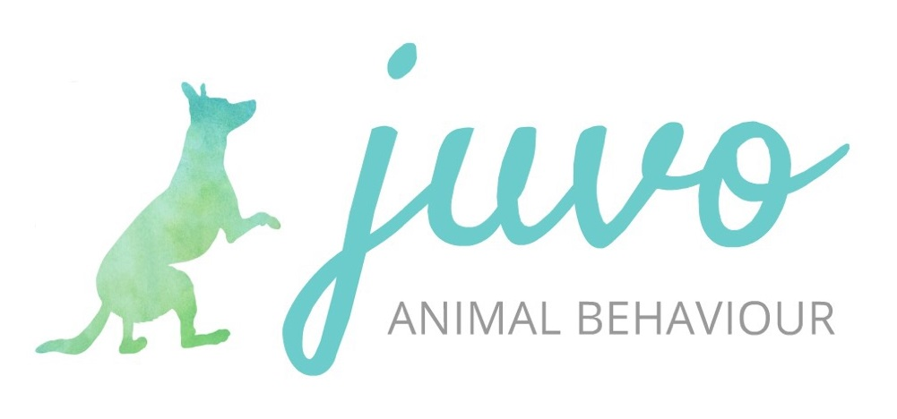
Puppy Training Booking Form

Once you have read and agree to the terms and conditions of booking, please complete this form honestly and in as much detail as you can.

Please select: Private sessions / Classes

Start date of course selected:

- How did you hear about Juvo Animal Behaviour?

About You

- Name:

- Names of any other people attending (please give ages of children):

- Telephone number:

- Email:

- Would you like your email address to be added to a mailing list to be sent useful resources and information about activities which may be of interest to you? Yes / No

- Address:

- Do you or anyone attending with you require communication support or have any medical or mobility requirements that I need to consider during our sessions?

About Your Puppy

- Name:

- Breed (if cross breed please specify any breeds known in the mix):

- Sex:

- Date of birth:

- Date of vaccinations:
(Please send me a photograph of your completed vaccination card. You must follow your vet’s advice regarding taking your puppy out after vaccinations. Please discuss this with me if you have concerns.)

- Name of veterinary surgery:

- Where did you obtain your puppy (i.e. private home, farm, breeder, rescue kennels, puppy farm):

- How long have you had your puppy at home?:

- Does your puppy have any dietary or health issues?:

- Describe your puppy’s personality:

- Describe your puppy’s behaviour towards other dogs:

- Describe your puppy’s behaviour towards people:

- Describe your puppy’s behaviour in new situations:

- Is there anything that your puppy is worried about or frightened of?:

- What do you hope to achieve by attending puppy training sessions?:

